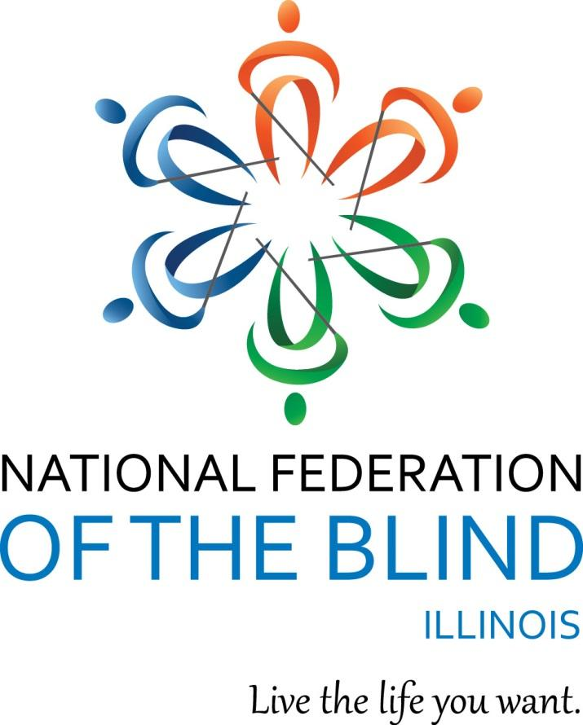

National Federation of the Blind of Illinois

State Convention 2026
“Together We Thrive”
AGENDA
NATIONAL FEDERATION OF THE BLIND
OF ILLINOIS
Annual Convention
October 23-25, 2026
Hyatt Regency Lisle
1400 Corporetum Drive
Lisle, IL 60532
630-852-1234
Hyatt.com

The National Federation of the Blind of Illinois is thankful to our 2026 state convention sponsors.
Diamond Level Sponsor:
The Chicago Lighthouse
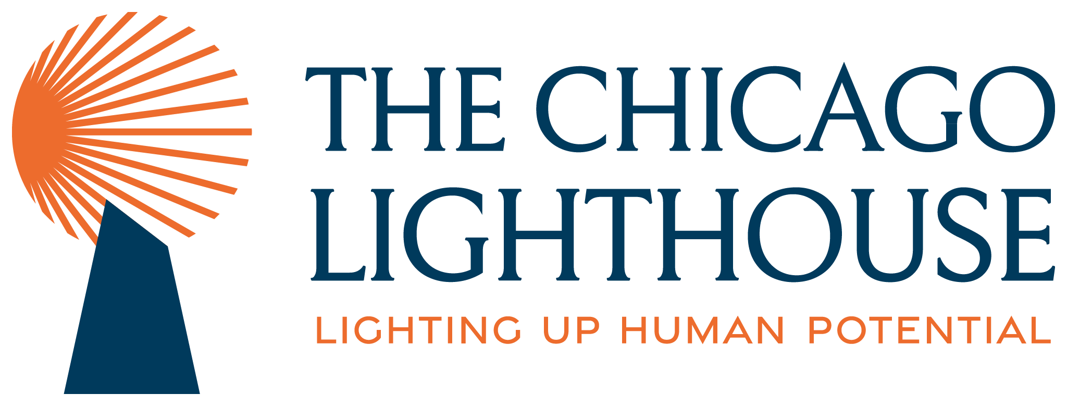

Gold Level Sponsors:
AIRA
Friedman Place

Members of NFBI wish to thank the following donors for their generous gifts:
The Trinity Fellowship Church
Episcopal Church Women
The Naperville Noon Lion's Club
Chapin Lions Club
Richard Lansden and Roger Hickman, Trustees, The Leona Stanford Vollintine Charitable Trust
Baptist Foundation of Illinois in memory of Richard V and Annette R. Grove
The Morrison family
Mrs. Cathy Randall, in honor of her loving husband, the late Robert “Bob” Randall
Zachary Kent
Illinois Association of Blind Merchants, a division of the National Federation of the Blind of Illinois
NFBI Chicago chapter, a chapter of the National Federation of the Blind of Illinois
NFBI At Large chapter, a chapter of the National Federation of the Blind of Illinois

Logistics: Announcements, Registration, Information Desk, and Smoking Policy
Announcements that you wish to be made from the convention floor during sessions MUST be texted to Marilyn Green at 312-343-8396. Jean Johnson is coordinating our information desk this year. Michal Nowicki and Kira O’Bradovich are handling the registration table at the convention. Tasabih Elfaki and Michelle Ault are running our door prize table.
If you wish to reach President Marilyn Green during sessions, please text 312-343-8396.
Smoking is not permitted in convention sessions.

Marilyn Green, President
National Federation of the Blind of Illinois (NFBI)
5128 N. Oak Park Ave.
Chicago, IL 60656
(312) 343-8396
NFBI Website
National Federation of the Blind Website

2026 Hyatt Regency Lisle Hotel/Convention Information
This quick article explains the layout of the Hyatt Regency Lisle which is our convention hotel for 2026. It also gives you basic information about the facilities and amenities.

Address and Phone:
The hotel is located at 1400 Corporetum Drive Lisle, IL 60532. The phone is: (630) 852-1234.

Sleeping Room Type:
There is one type of room, a standard guest room with 2 double beds. The guest rooms have a parlor with a sleeper sofa and chairs. The room rate for single and double occupancy is $129 per night and triple occupancy is $155 per night. Room rates are subject to local and state taxes.

Checkout:
Check in time is 3:00 p.m. Checkout time is 12:00 p.m.

Wi Fi:
There is free Wi-Fi in all lobbies and common areas. This includes our meeting rooms.

Facilities and Amenities:
There is a heated indoor pool and a 24-hour fitness center. There is lots of parking.

Layout:
The lobby is roughly in the shape of a large rectangle, with the top and bottom sides longer than the left and right walls. When you enter through the front doors you are in the lower left corner of the rectangle. The check-in desk is in the upper right-hand corner with the elevators for the sleeping rooms nearby. To get to them, turn right from the front doors to walk along the bottom length of the rectangle. You can follow a large carpeted section on this path. When the carpet turns left, turn with it. First, you will pass the elevators in a small hallway on the right. The desk will be further down in a large alcove on the right wall. There is a set of restrooms on this path if you continue past the check-in desk; they will be on the right.
The top of the rectangle is occupied by the hotel restaurant and bar. The seating areas for the restaurant are spread throughout the carpeted areas.
To get to the meeting rooms from the front doors, walk straight ahead on a tiled path. When you come across a carpeted area you will have the option to turn left or continue straight ahead. You may have noticed a change in the acoustics due to a change in the height of the ceiling. If you continue straight ahead on the carpets until they end and the hallway gains an echo the restrooms will be found at the far right corner.
If you turn left when you get to the carpets you will enter the hallway with all of the meeting rooms. All of the breakout rooms have two entrances and they are along the left side of the hall. First is Savannah A and B. Then Forest A and B. Lastly, at the far end of the hall is Woodland A and B.
The larger Arbor Ballroom takes up the right side of the hallway. There are four entrances for this space. Arbor A is at the far end of the hall and Arbor D wraps around the corner and it is closest to the restrooms.
There is a dog relief area outside the hotel’s main entrance. Hotel staff can help direct you to it.

Braille is Beautiful - Friday
Braille is Beautiful will take place on Friday. Please feel free to reach out to Debbie Stein if you wish to participate.
The information desk will be in the hotel main lobby on Friday, Oct. 23 from 2:00pm to 4:30 p.m., and in our general session room during general sessions. Registration will be in the hallway outside of the Arbor room on Friday from 2:00pm to 5:00 p.m. as well as on Saturday from 8:00 a.m. to 9:00 a.m. Exhibitors will be outside of our general session room.

Announcements:
Masks are optional at our convention. If attendees wish to wear a mask, they may feel free to do so. The National Federation of the Blind of Illinois will follow the convention hotel’s policies. We will additionally follow any guidelines mandated by the Centers for Disease Control (CDC) and local, state, or federal entities that may be enacted up until the close of our convention. Note that this statement is subject to change based on hotel policy, local, state, or federal regulations that may be placed in effect at the time of our convention.
The National Federation of the Blind of Illinois fosters a safe and inclusive environment for all at our events and meetings. We ask that you refrain from wearing or using excessive fragrances, including perfumes, colognes, and scented personal care products. Some people may have allergies to fragrances, the effects of which may be dangerous. Thank you for maintaining a safe and inclusive environment for all.
A cash bar will be staffed for our Friday night NFBI’S Got Talent and our Saturday night banquet. Please bring cash if you would like to enjoy an evening beverage.
You can help build a future of opportunity for the blind by becoming a member of our Dream Makers Circle. Your legacy gift to the National Federation of the Blind or the National Federation of the Blind of Illinois can be made in the form of a will, or living trust, an income generating gift, or by naming us as the beneficiary of a life insurance policy. For additional information, please contact Patti Chang at (773) 307-6440 or at pchang@nfb.org.
The PAC Plan allows members, affiliates, chapters, and others to give a regular and automatic donation to the Federation every month. All you need to provide is your credit card account identification information.
Because of the costs associated with operating the program, the minimum donation is $5 a month and there is no restriction on how much you donate.
Please sign up at the PAC table during convention to begin a new PAC contribution or to make changes to your current contribution. Your donation will help the blind live the lives they want.
In lieu of a kid's camp, the National Federation of the Blind of Illinois will provide a kid’s playroom at the state convention. The playroom, Savanna a &B, will be open during all general sessions and the banquet. The playroom will have toys and art supplies and all activities must be supervised by an adult. The National Federation of the Blind of Illinois will not be staffing the playroom and assumes no liability.

Welcome to our 2026 State Convention of the National Federation of the Blind of Illinois!!! Have a great convention, everyone!!

Friday, October 23, 2026, Afternoon

2:00-5:00 Exhibits - Hallway outside of Arbor Ballroom
AIRA
Chicago Lighthouse
Guide Dogs for the Blind
Illinois ABLE
Pathfinder Press

2:00-3:30 Building Blocks of Independence: Exploring New Spaces–
April Leachman, Home Management Instructor, Louisiana Center for the Blind, an NFB affiliated training center; Ruston, Louisiana, Woodland Conference Room
Entering an unfamiliar space does not have to feel overwhelming. Learn practical nonvisual techniques for exploring a hotel room, workplace, classroom, or other new environment; locating important features; organizing personal belongings; and becoming comfortable navigating the space independently.

2:00-4:30 Information Table –Jean Johnson, Hotel Lobby

2:00-6:00 Registration, Michal Nowicki, NFBI Treasurer and Kira O’Bradovich, NFBI Chicago chapter Treasurer
Hallway Outside of Arbor Ballroom

4:00-5:00 Resolutions – Michal Nowicki and Dustin Cather, Co-Chairs NFBI Resolutions Committee
Arbor Ballroom

Friday, October 23, 2026, Evening

5:00-6:30 General Membership Dinner and evening general session-
Cost $20, Arbor Ballroom
5:00-5:10 Welcome and Announcements – Marilyn Green, President NFBI
Pledge of Allegiance
Moment of Silence,
5:10-5:30 Dinner
5:30-6:20 Braille is Beautiful
6:20-6:30 Meet the 2026 State Scholarship Finalist-Patti Chang, 2026 State scholarship chair, National Federation of the Blind of Illinois
6:30-7:00 Break
7:00-11:00 NFBI’S Got Talent- Admission $5, includes your first performance
Sara Luna and Dustin Cather, NFBI Board Members, Arbor Ballroom
Join us for the National Federation of the Blind of Illinois’ Got Talent
Based on the popular TV show, America’s Got Talent. NFBI’s Got Talent invites everyone to participate as a soloist or group and perform a song of their choice. Bring an instrument and perform your favorite song. Each performance costs $5 per person. Don't forget our “Battle of the Chapters.” This year's theme is songs about collective action.

Saturday, October 24, 2026, Morning

Knowledge, Advocacy, and Collective Action Breakfast, Arbor Ballroom
7:00-7:10 Introductions
7:10-7:30 Breakfast Served
7:30-7:50 SSI, SSDI, and Employment: What You Need to Know– Jesse Shirek, Deputy Executive Director of Advocacy and Strategic Programs, National Federation of the Blind
How does employment affect Supplemental Security Income (SSI) or Social Security Disability Insurance (SSDI), and what should families know about benefits for children? Join us for practical information about eligibility, work incentives, benefits for children, and the transition to adulthood, with time to ask questions and address common misconceptions.
7:50-8:10 Randolph Shepherd and the Power of Collective Action–Nicky Gacos, President, National Association of Blind Merchants, a proud division of the National Federation of the Blind
Learn about the Randolph-Sheppard Act, the opportunities it provides for blind entrepreneurs, and NABM’s lawsuit involving the Department of War. This presentation will explain what is at stake and demonstrate how collective advocacy can protect the rights and economic opportunities of blind people.
8:10-8:25 Strengthening Our Movement: From Personal Stories to Collective Action-Jesse Shirek, Deputy Executive Director of Advocacy and Strategic Programs
Every member has experiences, knowledge, and talents that can strengthen our movement. Learn how personal stories can support advocacy, influence decision-makers, and encourage others to become involved. Explore practical ways you can contribute through chapters, divisions, committees, legislative outreach, and other collective efforts.
8:25-8:30 The Movement Needs You!–
Let’s take the final five minutes to consider your talents, skills, and passions. How can you use them to strengthen our movement? Whether you share your experiences, join a committee, welcome new members, or become more active in your local chapter, there is a place for you. Build the National Federation of the Blind and live the life you want!

8:00 - 9:00 Registration
Michal Nowicki, NFBI Treasurer and Kira O’Bradovich, NFBI Chicago chapter, Treasurer
Outside of Arbor Ballroom
Late registration, see Michal Nowicki in General Sessions

8:00 - 11:00 Exhibit Hall
Outside of Arbor Ballroom
Visit our 2026 state convention exhibitors. This will be our final opportunity to browse the hall and access their products, programs, and services.

9:00-11:30 Breakouts
Breakout 1
9:00-10:00 Independent Living Problem-Solving Lab, April Leachman, Home Management Instructor, Louisiana Center for the Blind, Ruston, Louisiana
How can nonvisual techniques make everyday tasks easier and more efficient? Bring your questions and challenges to this interactive breakout, where a blind instructor will share practical strategies, demonstrate useful techniques, and help participants develop solutions they can use in their daily lives.
Breakout 2
9:00-10:00 Illinois Association of Blind Merchants Division meeting
Ed Birmingham, President, Illinois Association of Blind Merchants
Join the Illinois Association of Blind Merchants for a discussion of issues, priorities, and opportunities affecting blind merchants and entrepreneurs. Learn more about the division’s work and how collective action can strengthen opportunities for blind business owners across Illinois.
Breakout 3
10:20-11:30 Everybody Can Dance: Learn the Foxtrot Breakout
Patti Chang, 2nd Vice President, National Federation of the Blind of Illinois and Francisco Chang, NFBI Chicago chapter member
Dance is for everyone—including blind people! Whether you already love to dance or are ready to challenge what you thought was possible, join our blind instructor and her dance partner for a fun and welcoming introduction to the rhythm and steps of the foxtrot.
Breakout 4
10:20-11:30 Family Connections: A Conversation for Parents and Children Breakout
Deborah Kent Stein, NFB BELL coordinator, National Federation of the Blind of Illinois
Connect with families of blind children at the NFBI convention! Parents can share experiences, exchange ideas, and build friendships while children join the conversation or spend time getting to know one another. Children are welcome to attend with their parents.

11:30-12:00 Break

Saturday, October 24, 2026, Afternoon

12:00-2:30 General Session
Arbor Ballroom
12:00-12:05 Welcome and Announcements – Marilyn Green, President NFBI
12:05-12:25 Lunch Served
12:25-12:40 A Year of Progress: The National Association of Blind Merchants– Nicky Gacos, President, National Association of Blind Merchants
12:40-12:55 News from the Illinois Bureau of Customer & Community Blind Services–Heather Speth, Assistant Bureau Chief, Illinois Bureau of Customer & Community Blind Services
12:55-1:10 The Louisiana Center for the Blind, April Leachman, Home Management Instructor, Louisiana Center for the Blind, an NFB affiliated training center
1:10-1:55 National Report – Jesse Shirek, Deputy Executive Director of Advocacy and Strategic Programs, National Federation of the Blind; National Rep., National Federation of the Blind
1:55-2:05 2025 Washington Seminar & the NFB Legislative Priorities-Denise Avant and Dustin Cather, 2026 Federal Legislation co-chairs, National Federation of the Blind of Illinois
2:05-2:20 Hear It from Us!: NFB BELL & NFB STEM2U Students Share their Stories– Debbie Stein, Illinois NFB BELL Coordinator; Amy Yount, Lead Teacher, Illinois NFB BELL Springfield ; Alaula Sprecher, Illinois NFB STEM2U co-coordinator; and the Illinois NFB BELL &NFB STEM2U students
2:20-2:30 2026 NFB State and National Scholarship Programs– Patti Chang, 2026 State Scholarship Committee Chair, National Federation of the Blind of Illinois

2:30-3:00 Break

Saturday, October 24, 2026, Afternoon continued

3:00-5:00 General Session, Arbor Ballroom
3:00-3:05 Call to Order
3:05-3:20 The Coast-to-Coast Movement Challenge and Other Ways to Give– Patti Chang, Executive Director of
Mission Advancement, National Federation of the Blind
3:20-3:30 Closing Remarks – Jesse Shirek, NFB National Representative
3:30-4:00 State Reports
Treasury Report – Michal Nowicki, Treasurer, National Federation of the Blind of Illinois
Presidents Report – Marilyn Green, President, National Federation of the Blind of Illinois
4:00-4:30 Resolutions – Michal Nowicki and Dustin Cather, Co-chairs
4:30-5:00 Elections
Executive Board Seats
President, currently held by Marilyn Green
1st Vice President, currently held by Denise Avant
2nd Vice President, currently held by Patti Gregory Chang
Secretary, currently held by Deborah Kent Stein
Treasurer, currently held by Michal Nowicki

General Board Seats
Board Seat 5, currently held by Cathy Randall
Board Seat 6, currently held by Bridgid Burke
Election of Delegate and Alternates to 2027
National Convention

5:00 Adjourned

Saturday, October 24, 2026 Evening

5:20-5:50 Scholarship Committee Meeting – President’s Room

6:00-7:00 Hospitality – Fourier Outside of Arbor Ballroom

Annual Banquet -Arbor Ballroom
MC – Denise Avant, 1st Vice President
National Federation of the Blind of Illinois
7:05-7:10 Welcome and Invocation – Eileen Truschke, Member, National Federation of the Blind of Illinois, Chicago chapter
7:10-7:45 Dinner
7:45-7:55 Blind Unbound: Museum of the Blind People’s Movement-Patti Chang, Executive Director of Mission Advancement, National Federation of the Blind
7:55-8:10 Fifteen for Funds – Dustin Cather, President, National Federation of the Blind of Illinois Chicago chapter
8:10-8:45 Banquet Speech – Jesse Shirek, NFB National Representative
8:45-9:00 Scholarship Award – Patti Chang, 2026 Scholarship chair, National Federation of the Blind of Illinois
9:00 Adjourned

9:00-11:00 Hospitality
When the banquet adjourns, the evening doesn’t have to end! Stay awhile to fellowship, share stories, and make new connections with fellow convention attendees. The cash bar will remain open, so stop by to purchase a soft drink or an adult beverage and continue enjoying the evening.

Sunday, October 25, 2026, Morning

8:00-10:00 More Than Words: Putting Our NFB Philosophy into Action–
Arbor Ballroom
Join us for breakfast and an interactive exploration of our NFB philosophy! What does it mean to live the life you want? Together, we will explore our shared belief that blindness does not define us or our future, challenge the low expectations that stand between blind people and our dreams, and demonstrate the collective power that makes us who we are. Come ready to participate, share, and put our philosophy into action!

Thank you for all you do!
Thanks to the Special Events Committee, the Sound committee, and all others who have served on committees, worked registration and information tables, secured door prizes, and appeared on the agenda. You have helped make this convention a tremendous success.

NFB PLEDGE
I pledge to participate actively in the efforts of the National Federation of the Blind to achieve equality, opportunity, and security for the blind, to support the policies and programs of the Federation, and to abide by its constitution.

BELIEF MESSAGE
The National Federation of the Blind advances the lives of its members and all blind people in the United States. We know that blindness is not the characteristic that defines you or your future. Every day we raise the expectations of blind people because low expectations create obstacles between blind people and our dreams. Our collective power, determination, and diversity achieve the aspirations of all blind people.

