NFB OF ILLINOIS
BELL ACADEMY
BRAILLE ENRICHMENT FOR LITERACY AND LEARNING July 29-August 9, 2019
NFB BELL Academy Chicago
TOP TEN BELL
Ringers of 2019
10. Yoga
9. Mentors
8. White Sox Park
7. ADL Bins
6. Drawing
Boards
5. Ice Cream
4. Solarium
3. Cooking
2. New Friends
1. Walking Tacos

New Amazing Activity This Summer
This summer, the students had the opportunity to build their daily living skills by completing a variety of tasks included in our Activities of Daily Living Bins(ADL Bins). The ADL Bins included the following tasks: counting/sorting money, tying shoes, sorting/folding socks, cleaning a surface, using a stapler, hanging shirts on a hanger, opening/applying a Band-Aid, and cleaning a pair of glasses. Each student learned tips and tricks that he or she can use when completing these tasks at home or in his or her community.

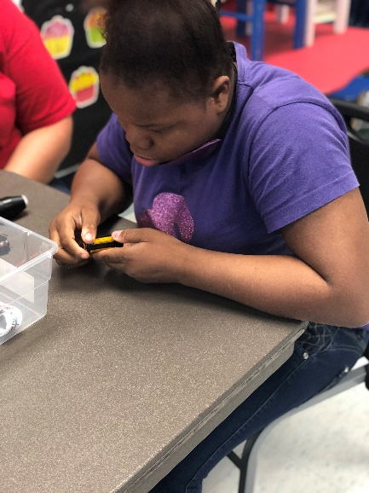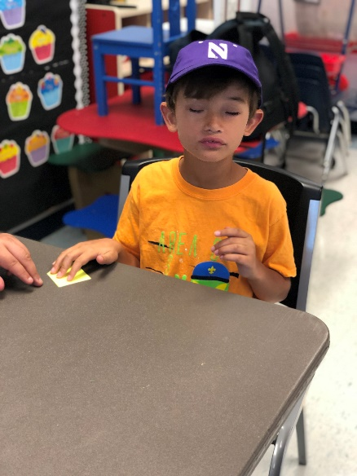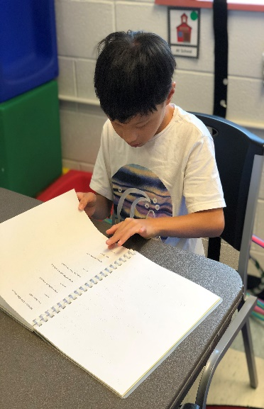
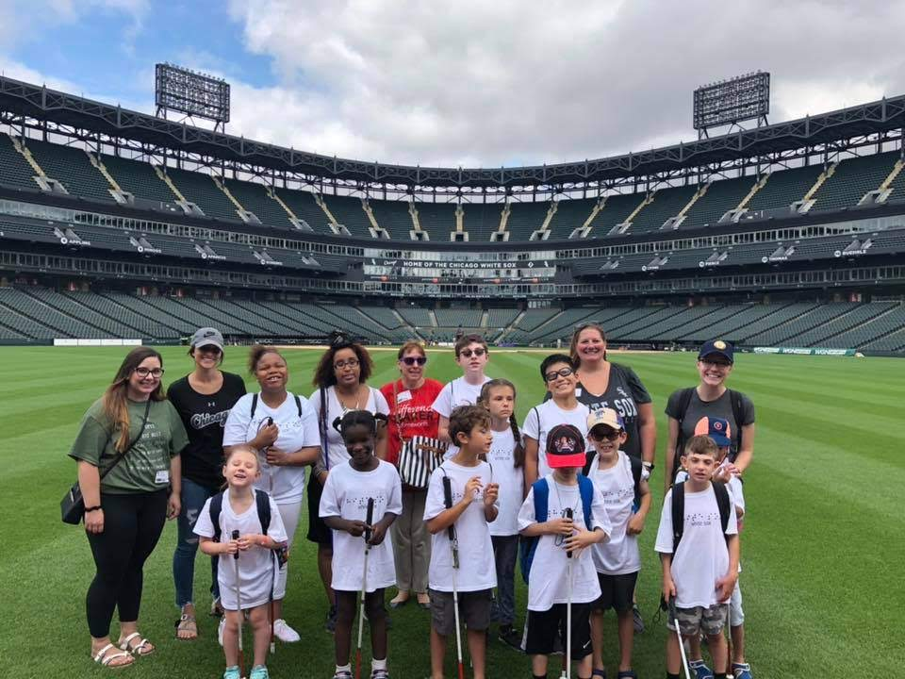

Please join us

NFB of Illinois State Convention
October 18-20 2019
Springfield, Illinois
Goals and Fun

What an adventurous couple of weeks filled with lots of fun travel opportunities! Our four field trips this year consisted of a walk to the grocery store and Baskin Robbins, an L ride to the park for beep kickball, a bus trip to Guaranteed Rate Field to explore the field, and combination of all three to get to a touch/audio tour of the African House at Lincoln Park Zoo. While all of our field trips were a blast, our trip to the baseball field and to the zoo really challenged our cane skills and gave us the opportunity to explore new places! At Guaranteed Rate Field, we explored the home plate area, ran some of the bases, and practiced our outfielder skills by jumping into the wall! They also showed us where they stored the dirt and gravel (which was great because you could REALLY smell it)!

