NFB OF ILLINOIS
BELL ACADEMY
BRAILLE ENRICHMENT FOR LITERACY AND LEARNING June 10-14, 2019
NFB BELL Academy Springfield
TOP TEN BELL
Ringers of 2019
10. Yoga
9. Mentors
8. Slate & Stylus
7. YMCA
6. Drawing
Boards
5. Beep Kickball
4. Hotel Pizza Party
3. Cooking
2. New Friends
1. Walking Tacos
BRAILLE, NON-VISUAL AND TRAVEL SKILLS
"What is BELL?" is asked often. It is difficult to describe the awesomeness that is the NFB BELL Academy. The opportunity to reinforce, instruct and build braille skills is just a start. By setting high expectations, incorporating instruction and providing the opportunity to practice new skills, the participants grow exponentially. If you ask a participant, they may say it is like school but FUN. The program also relies on our mentors, successful blind adults, to model skills and show that independence is not only attainable but needed, so that they may live the lives they want, in their futures.
The teachers are so thankful for allowing us to work with your children this summer. We have enjoyed every moment of it! -Lauren Mehalek and Amy Lund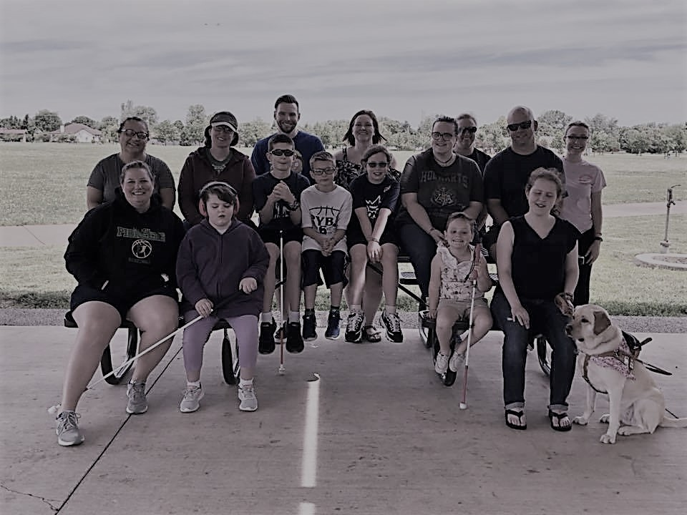
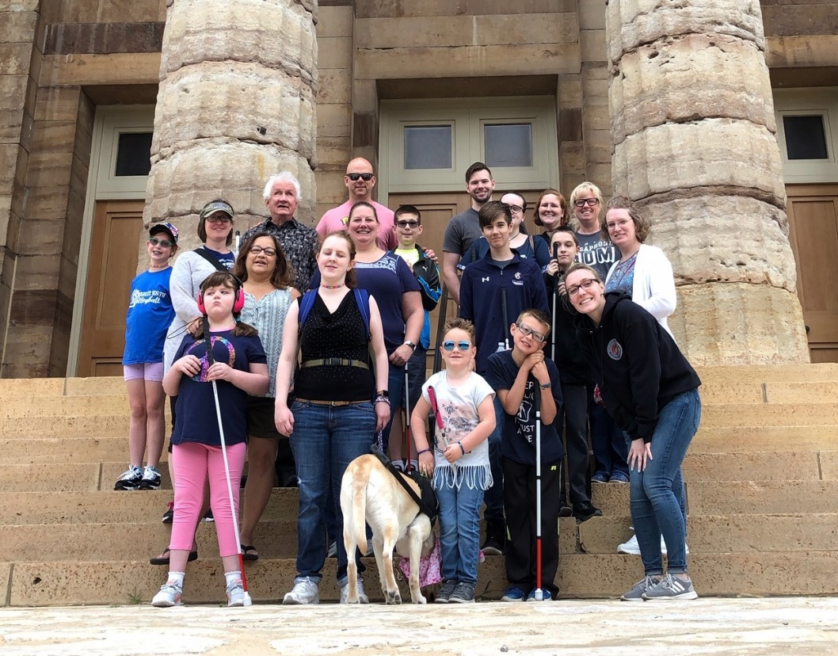

Please join us

NFB of Illinois State Convention
October 18-20 2019
Springfield, Illinois
Goals and Fun

What an exciting week filled with braille, cooking, extra cane practice, and so much more! The week started with each child setting goals for themselves. It was frequently said, “This was one of my goals to work on”. The kids were able to work on reading and writing braille, cooking goals in the kitchen as well as goals that focused on being more independent when traveling.
In just a few short days, our wonderful kids have made so many meals using nonvisual skills. This week’s menu consisted of pancakes, sausage, omelets in a bag, deli sandwiches and walking tacos. While walking tacos is the group favorite, the omelets in a bag gave a new cooking technique by boiling the egg mixture in a ziplock freezer bag.
The group was so fortunate to have amazing mentors in Bill, Katie and Alyssa! We loved having their experience, confidence and support as we worked together for a fun week. It could not have been done without them!
Springfield offers so many fun and unique opportunities for field trips. This year we enjoyed the biweekly farmers market. All enjoyed smelling the different herbs, tasting snap peas and purchasing something offered at the market. After the delicious snack, the group headed to the Kidzeum. This fun museum has three floors of interactive activities that everyone enjoyed!
We ended our week as we end each day, our BELL RINGERS. It is important to not only set goals but to celebrate the progress made towards them. We are so proud of the kids and the steps they made this week towards their own goals.

