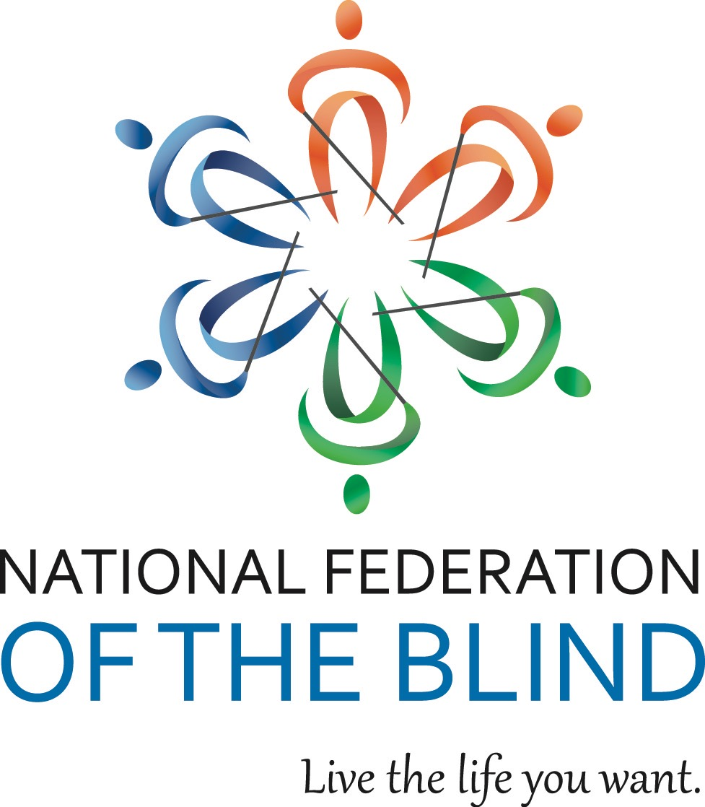

NATIONAL FEDERATION OF THE BLIND OF ILLINOIS

2015 CONVENTION BULLETIN

“BELIEVE AND ACHIEVE”

On October 30th, 31st, and November 1st, 2015, enthusiastic Federationists will assemble in Naperville to renew our dedication in the pursuit of security, equality, and opportunity for all blind people.

The site for our convention will be the Chicago Naperville Marriott, 1801 Naperville Blvd., Naperville, IL 60563 phone (630) 505-4900. Room rates are $93 per night plus applicable taxes. Please indicate that you are with the NFBI to get this special rate. Make reservations by calling (800) 228-9290. Reservations must be guaranteed with a credit card or a one night deposit. Our cutoff date for reservations is October 9th.

This year’s convention will kick off with Friday afternoon seminars as well as an afternoon resolutions committee meeting. Come learn and participate in our governing process.

The Resolutions Committee will be chaired by Patti Chang. ALL resolutions must be submitted by October 16th, 2015. She may be contacted at (773) 307-6440 or e-mail at [pattischang@gmail.com](mailto:pattischang@gmail.com).

IABS IDOL will occur Friday evening. Those wanting to perform during the IABS Idol should contact IABS by e-mailing Katie Leinum at [kayteaell@gmail.com](mailto:kayteaell@gmail.com) Please put IABS IDOL in your subject line.

Our general session will convene on Saturday, October 31st, at 9 a.m. During Saturday’s general sessions we will hear a National Report regarding NFB happenings delivered by our National Representative, Mr. James Gashel, secretary of NFB Board of Directors. We will have an employment panel, plus seminars on exercise, advocacy during the rehabilitation service process, and the history and current law of the Randolph-Shepard Vending Facility Act. Plus, we will also hear from our Freedom Link and BELL participants just to name a few of our agenda items.

We will have a Saturday parent breakfast and a Sunday student breakfast. We will have both student and parent luncheons on Saturday. In addition, there will be a breakout session for parents of blind children, where Mr. Gashel, will give a presentation on the KNFB Reader for mobile devices.

Saturday evening will culminate with our annual banquet, featuring an inspiring address from our National Representative, Mr. James Gashel. See:  <https://nfb.org/james-gashel-bio>. We will also see the much-anticipated scholarship awards.

Sunday morning’s general session will begin with Braille is Beautiful and we will hear from other blind people sharing their experiences. Resolutions will be voted on during the Sunday morning session. Adjournment is scheduled for 12:00 PM on November 1st.

Advance registration for the convention made before October 16th is $5. Registration after that date or at convention will be $15. This year you can register and pay online at [www.nfbofillinois.org](http://www.nfbofillinois.org). If you are mailing your form and payment, the registration form and fees for breakfasts, luncheon, and banquet should be sent before October 16th to Patti Chang, 6919 W. Berwyn Ave. 60656, Treasurer NFBI. Checks or money orders should be made payable to NFB of Illinois. Please do not send cash.

We will host a meeting for parents of blind children at 7 a.m. on Saturday. The student business meeting will be held on Sunday morning at 7:00 a.m. These are both breakfast meetings.

Two breakfasts are planned. Their cost is $10. We will have two luncheons for all those interested in student and/or parent issues on Saturday. The cost for either luncheon will be $15. The banquet on Saturday night will start at 7 p.m. and tickets will cost $30.

Those with special dietary needs for any of the meals should contact Patti Chang, (773) 307-6440 or [pattischang@gmail.com](mailto:pattischang@gmail.com). The deadline for such requests is October 16th.

Kids’ Kamp (childcare) will be available on Saturday from 8:30 a.m. to 5:30 p.m. Kids’ Kamp is free to all children ages 3 to 12 who are registered for the convention. A separate release form must be filled out at time of registration.

For those needing financial assistance to attend the convention, all applications must be submitted to President Denise Avant no later than September 1, 2015 at 3410 N. Lake Shore Dr. Apt. 4L-M, Chicago, Il. 60657 or e-mail [davant1958@gmail.com](mailto:davant1958@gmail.com). The form to fill out for financial assistance from the James ChappelL and Carmen Dennis Memorial Fund is available on our web site at [www.nfbofillinois.org](http://www.nfbofillinois.org) or one will be mailed to you upon request.

Federation conventions change the lives of blind and sighted people alike! Don’t miss out on this opportunity for change! Join us for our best convention yet! Come and live the life you want!!!

Special thanks go to our lead sponsor, Invesco. For more information on Invesco see [www.invesco.com](http://www.invesco.com).

s