O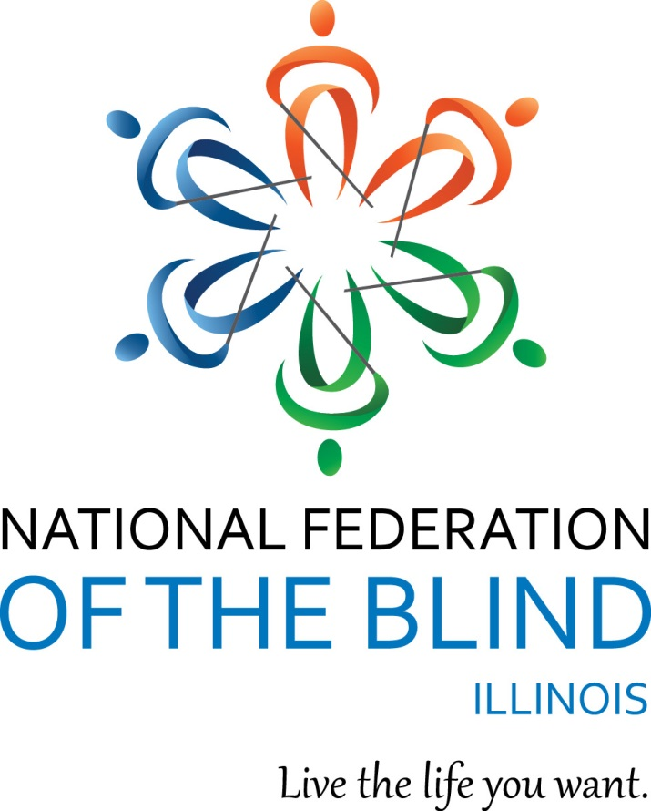

National Federation of the Blind of Illinois

State Convention 2022
“Together Again”

AGENDA
NATIONAL FEDERATION OF THE BLIND
OF ILLINOIS
Annual Convention
October 28-30, 2022

Naperville Marriott
1801 Naper Blvd
Naperville, IL 60563
630-505-4900
Naperville Marriott Website

The National Federation of the Blind of Illinois is thankful to our 2022 state convention sponsors.

Gold Level Sponsors:
Democracy Live
https://www.democracylive.com

Schaumburg-Hoffman Lions Club
https://e-clubhouse.org/sites/schaumburghoffmanil/contact.php

Members of NFBI wish to thank the following donors for their generous gifts:

The Aileen S. Andrew Foundation

Illinois Prairie Community Foundation Inc.

Community Fund Quad Cities Mildred Crespin-Croegaert Fund

Mr. Harold W. Knapheide III, in honor of his mother, the late Mary MacDill Knapheide

Gary and Debbie Lindon Family Fund via Jewish Federation of Metropolitan Chicago

The Friends and Family of Estelle Kron for In Memoriam Gifts

The Naperville Noon Lion's Club

The Pangere Corporation

The Chicago Lighthouse

Richard Lansden and Roger Hickman, Trustees, The Leona Stanford Vollintine Charitable Trust

Logistics: Announcements, Registration, Information Desk, and Smoking Policy

Announcements that you wish to be made from the convention floor during sessions MUST be submitted to the information desk in the convention hall. Kira O’Bradovich is coordinating our information desk this year. Michal Nowicki and Patricia Olson are handling the registration table at convention. Teresa Fabre and Mary Grunwald are running our door prize table.
If you wish to reach President Marilyn Green during sessions, please text 312-343-8396.
Smoking is not permitted in convention sessions.

National Federation of the Blind of Illinois
Marilyn Green, President
5128 N. Oak Park Ave.
Chicago, IL 60656 (312) 343-8396
National Federation of the Blind of Illinois (“NFBI”)
NFBI Website
National Federation of the Blind Website

2022 Naperville Marriott Hotel/Convention Information
Naperville Marriott Website

This quick article explains the layout of the Naperville Marriott which is our convention hotel for 2022. It also gives you basic information about the facilities and amenities.

Address and Phone:
The hotel is located at 1801 N. Naper Blvd Naperville, IL 60563. The phone is: (630) 505-4900.

Sleeping Room Types:
There are two types of rooms. A Suite and a Standard Room. The suites have a parlor with a sleeper sofa and two easy chairs. The room rate for 1 King bed is $109 and the room rate for 2 Queen beds is $119 per night. All rooms have hair dryers and coffee makers. Connecting rooms are available upon request.

Keycards and Electrical Power:
This hotel is modernized. You need to insert your keycard in a slot inside your room to the side of the door to turn your power on. Leave it in the slot until you exit your room. When you remove it, the power goes off again.

Checkout:
Check in time is 3:00 p.m. Checkout time is 12:00 p.m.

Wi Fi:
There is free Wi Fi in all lobby and common areas. This includes our meeting rooms.

Facilities:
There is an indoor pool, fitness room, and Jacuzzi. There is lots of parking especially by the side door.

Layout:
If you enter through the main doors, the layout is as follows: the Starbucks is to the left. You should walk ahead to where the tiled flooring forms a cross. If you turn left at the "lobby cross" with the doors at your back, you can enter Starbucks by taking the first left. If you take a right, you can go to the elevator bank. If you pass the elevators, you head toward the meeting rooms.
From the front door, if you simply bypass the crossing of the tiled portions of the lobby and keep going straight, you will find our information desk on your left and the hotel desk on your right. If you pass both, there is a restaurant directly ahead. You can find the bar which also serves food from the restaurant by going left after passing the hotel desk. The bar will be on your right although people can also sit on the left side at this point in the lobby.
If you reorient to the lobby desk, at this point it is easier. If you are standing facing the hotel front desk, the elevator bank is down the tiled hall to the right of the front desk. There are three elevators on your left side down that hall a short way. They are fast.
Our meeting rooms are laid out past the elevator bank. Right after the elevators there is a cash machine on your left and restrooms on your right. Past those, first you come to a hallway where conference rooms A, B, and C are on your left headed away from the lobby. Conference rooms D, E, and F are on your right. Past that Hall the hall divides at a Y. There is another set of restrooms down by the other conference rooms near Bailey. If you go left, you come to Bailey-Hobson and if you go right you will get to the Naper Ballroom. We are in the Naper Ballroom on Friday, October 28, all general sessions, the luncheon and the banquet on Saturday, October 29, and for the student breakfast and general sessions on Sunday, October 30. Outside of the Naper Ballroom we will have exhibits and we will have our registration.
There is a dog relief area outside of the Naper room. Exit and walk a short way, then take a 45 degree left turn. There is a cement patio area on the left about 30 ft. up. At the end of the patio, you will find a grassy area with trees which will work well for dog relief. There is even a hydrant.

Braille is Beautiful - Sunday
Braille is Beautiful will take place on Sunday. Please feel free to reach out to Debbie Stein if you wish to participate.

Set-up for Naper Ballroom:
When you enter the Naper Room it is wider left to right and shorter going ahead from the doors. You enter at the back of the room. We will have info, sales, and IABS in the back of the room and head table/stage will be furthest from the doors by the windows. Door prize table will be on the right as you face the stage.

Have a great convention, everyone!

IABS, INFORMATION, PAC AND SALES TABLES
The information desk will be in the hotel main lobby on Friday Oct. 28 from 2:00 to 4:30 p.m., and in our general session room during general sessions. Registration will be in the hallway outside of the Naper room on Friday from 4:00 through 7:00 p.m. as well as on Saturday from 8:00 to 9:00 a.m. The sales table for IABS will be in the back during general sessions. The PAC plan table will also be in the back during general sessions. Exhibitors will be outside of our general sessions room.

Announcement:
You can help build a future of opportunity for the blind by becoming a member of our Dream Makers Circle. Your legacy gift to the National Federation of the Blind or the National Federation of the Blind of Illinois can be made in the form of a will, or living trust, an income generating gift, or by naming us as the beneficiary of a life insurance policy. For additional information, please contact Patti Chang at (773) 307-6440 or at pchang@nfb.org.

The PAC Plan allows members, affiliates, chapters, and others to give a regular and automatic donation to the Federation every month. All you need to provide is your checking, savings or credit card account identification information.
Because of the costs associated with operating the program, the minimum donation is $5 a month and there is no restriction on how much you donate.
Please sign up at the PAC table during convention to begin a new PAC contribution or to make changes to your current contribution. Your donation will help the blind live the lives they want.

IABS Fundraiser- IABS Pie Palooza- the Illinois Association of Blind Students wants to have some fun by throwing a pie at our state and national leaders! All monies will go to help IABS. So please be generous. The coordinator of this event is Sara Luna, NABS 2nd Vice President and IABS 1st Vice President.

Welcome to our 2022 State Convention of the National Federation of the Blind of Illinois!!!

Friday, October 28, 2022, Afternoon
12:00-1:30 Let’s make guacamole– Teresa Fabre, IABS Secretary, Naper Ballroom

2:00-3:30 Sculpting with Clay – Ralph Cossentino, Instructor of Figurative Sculpture at the Palette and Chisel in Chicago, Naper Ballroom

2:00-4:30 Information Table – Kira O’Bradovich, Hotel Lobby
4:00-7:00 Registration, Michal Nowicki, NFBI Treasurer and Pat Olson, NFBI Board member
Hallway Outside of Naper
4:00-5:00 Resolutions – Michal Nowicki and Dustin Cather, Co-Chairs NFBI Resolutions Committee
Naper Ballroom

October 28, 2022, Evening
4:00-7:00 Registration – Michal Nowicki and Pat Olson, Hallway outside of Naper Ballroom
4:00-7:00 Exhibits - Hallway outside of Naper
AceIt Assistive Technology Services LLC
Guide Dogs for the Blind

5:00-7:00 General Membership Dinner -
Cost $15, room TBA
5:00-7:00 Scholarship Dinner – (Finalists, Committee Members, and Invited Guests)
Conference Room D
700-11:00 IABS IDOL - Admission $5, includes your first performance
Ellen Bartelt, IABS President, Naper Ballroom
Join us for the Illinois Association of Blind Students IABS Idol
Based on the popular TV show, American Idol. IABS Idol invites everyone to participate as a soloist or group and perform a song of their choice. Wear a costume and celebrate Halloween, bring an instrument and perform your favorite song. Each performance costs $5 per person. Don't forget our “Battle of the Chapters.” This year's theme is travel related songs.

Saturday, October 29, 2022, Morning

Parent and Student Breakfast
Naper Ballroom
7:00-7:10 Introductions
7:10-7:30 Breakfast Served
7:30-7:45 I Taught the Sighted and the Blind: My Journey as an Elementary School Teacher and a Cane Travel Instructor - Adelmo Vigil, National Federation of the Blind Board member and 1st Vice President of the National Federation of the Blind of New Mexico
7:45-8:25 From High School Senior to College Freshman– Tasabil Elfaki, Freshman, Northern Illinois University, DeKalb, Illinois and Vance Hertter, Freshman, Eastern Illinois University, Charleston, Illinois

8:00 - 9:00 Registration
Michal Nowicki, NFBI Treasurer and Pat Olson, NFBI Board Member
Outside of Naper Ballroom

Later registration, see Michal Nowicki in General Sessions

8:00-9:00 Exhibits

October 29, 2022, Morning Sessions
9:00-11:30 General Session
Naper Ballroom
9:00-9:10 Welcome and Announcements – Marilyn Green, President NFBI
Pledge of Allegiance
Moment of Silence, Nadia Sherman – August 10,1997 to June 5, 2022- Chicago Chapter
Edwin Rodriguez– September 19, 1959-May 23, 2022- Chicago Chapter
9:10-9:55 National Report – Adelmo Vigil, Board member, National Federation of the Blind and 1st Vice President, National Federation of the Blind of New Mexico
9:55-10:10 Census Data Collection can fuel Federation Initiatives-Ileana C. Serrano, Data Dissemination Specialist, U.S. Census Bureau
10:10-10:20 Let’s Read Together -Joe Natale, Chief Deputy Director, Illinois State Library
10:20-10:30 National Association of Blind Students Report – Elizabeth Rouse, Treasurer, National Association of Blind Students, a division of the NFB
10:30-10:50 Electrifying STEM Accessibility in Illinois-Dr. Natalie L. Shaheen, Assistant Professor of Low Vision and Blindness, Illinois State University, Normal, Illinois; Mr. Matthew Hagaman, Instructional Designer, Center for Mathematics, Science and Technology, Illinois State University, Normal, Illinois; Mr. Addison Graham, Senior, Low Vision and Blindness Major, Illinois State University, Normal, Illinois
10:50-11:10 An NFB Training Center: What to Expect-Jennifer Kennedy, Director, Blindness in New Dimensions (Blind Inc.), Minneapolis, Minnesota
11:10-11:30 The State of Rehabilitation Services for the Blind of Illinois -Kim Borowicz, Bureau Chief, Illinois Bureau of Blind Services
11:30-12:00pm Break

12:00 pm-1:30pm Student/Parent lunch – Naper Ballroom
12:00-12:15 Lunch
12:15-12:25 Student Excellence Award – Ellen Bartelt, President, Illinois Association of Blind Students
12:25-12:40 2022 Scholarship Finalists – Deborah Stein and Patti Chang, Scholarship Co-chairs, National Federation of the Blind of Illinois
12:40-12:50 My Summer in NFB EQ - Dr. Natalie Shaheen, National Center for Blind Youth in Science Project Director, Bloomington, IL and the NFB EQ students
12:50-12:55 Illinois Career Mentoring Program– Tasibil Elfaki, Freshman, Northern Illinois University, DeKalb, Illinois
12:55-1:05 Growing with the Federation – Elizabeth Rouse, Treasurer, National Association of Blind Students
1:05-1:30 Cross the Line- Illinois Association of Blind Students

October 29,2022 Afternoon

Breakouts 1:45-3:00 pm
1:45-3:00 Instructional Dance Breakout
Conference Room F
Patti Chang, 2nd Vice President, National Federation of the Blind of Illinois and Teresa Fabre, Secretary, Illinois Association of Blind Students

Breakout 2
Conference Room D
1:45-3:00 Technology Breakout: IPads and IPhones
Ather Jammoa, Adaptive Technology Instructor, Eye Learn LLC, Detroit, Michigan

October 29, 2022, Afternoon continued

3:15-5:00 General Session
Naper Ballroom
3:15-3:30 Broadway and More: Audio Description– Martin Wilde, Founder of Arts Access International and Professional Audio Describer
3:30-4:10 Personal Reflections: Celebrating Family History Month– Sara Luna, 2nd Vice President, National Association of Blind Students; Teresa Fabre, Secretary, Illinois Association of Blind Students; Dilip Shah, Member, Chicago chapter
4:10-4:30 Independent Voting: A Presentation from Democracy Live-Melissa Carney, Educational Outreach Consultant, Democracy Live
4:30-4:35 Midwest Student Seminar-Ellen Bartelt, President, Illinois Association of Blind Students
4:35-4:40 2023 NFB State and National Scholarship Programs – Deborah Stein and Patti Gregory Chang, Co-chairs Scholarship committee, National Federation of the Blind of Illinois
4:40-4:45 Washington Seminar 2022 and the NFB Legislative Initiatives – Denise Avant and Dustin Cather, Federal Legislation Co-chairs, National Federation of the Blind of Illinois
4:45-4:50 Ways to Support the NFB – Patti Chang, Director of Outreach, National Federation of the Blind
4:50-5:00 Braille Enrichment Literacy and Learning (BELL) – Deborah Kent Stein, Illinois BELL Coordinator & Amy Lund, Illinois BELL Lead Teacher
5:00 Adjourn

Saturday, October 29, Evening

5:20-5:50 Scholarship Committee Meeting – President’s Room

6:00-7:00 Hospitality – Fourier Outside of Naper Ballroom

7:00 Annual Banquet -Naper Ballroom
MC – Denise Avant, 1st Vice President
National Federation of the Blind of Illinois
7:05-7:10 Welcome and Invocation – Eileen Truschke, Member, National Federation of the Blind of Illinois, Chicago chapter
7:10-7:15 IABS Pie Palooza – Ellen Bartelt, President, Illinois Association of Blind Students
7:15-7:25 The future of our youth and Education Programs– Deborah Stein Secretary, National Federation of the Blind of Illinois
7:25-7:55 Dinner
7:55-8:15 Awards-Patti Chang and Cathy Randall
8:15-8:30 Fifteen for Funds – Cathy Randall, Board member, National Federation of the Blind of Illinois
8:30-8:50 Banquet Speech – Adelmo Vigil, NFB National Representative
8:50-9:00 Scholarship Awards – Deborah Kent Stein and Patti Chang, Scholarship Co-chairs, National Federation of the Blind of Illinois
9:00 Adjourned

9:00-11:00 Hospitality

Sunday, October 30, 2022

7:00-8:30am Illinois Association of Blind Students Breakfast and Business Meeting
IABS President, Ellen Bartelt
Note: All are welcome who are interested in student issues but please note that only those who have paid IABS dues may vote in elections. Please see Glenn Moore or any IABS Board Member to pay dues. We will be collecting money at the registration table and at the IABS table during convention.
7:00-7:30 Breakfast
7:30-7:35 Treasurer’s Report - Glenn Moore, Illinois Association of Blind Students Treasurer
7:35-7:45 Presidents Report – Ellen Bartelt, President, Illinois Association of Blind Students
7:45-8:00 Elections
President, currently held by Ellen Bartelt
1st Vice President, currently held by Sara Luna
2nd Vice President, currently held by Natalio Abar
Secretary, currently held by Teresa Fabre
Treasurer, currently held by Glenn Moore
General Board Seat 1, currently held by Elizabeth Sprecher
General Board Seat 2, Currently Held by Debbie Stein
8:00-8:10 Old Business
New Business
8:10-8:15 Illinois Association of Blind Students Board of Directors Photo Op
8:15 Meeting Adjourned

October 30, 2022 Morning continued

9:00-12:00 General Session
Naper Ballroom
9:00-9:05 Call to Order
9:05-9:30 Braille Is Beautiful: A Dramatic Reading - Deborah Stein, Author and Secretary, National Federation of the Blind of Illinois
9:30-9:40 Closing Remarks – Elizabeth Rouse, NABS Student Representative
9:40-9:50 Closing Remarks – Adelmo Vigil, NFB National Representative
9:50-10:30 State Reports
Treasury Report – Michal Nowicki, Treasurer, National Federation of the Blind of Illinois
Presidents Report – Marilyn Green, President, National Federation of the Blind of Illinois
10:30-11:00 Chapter Reports
Illinois Association of Blind Merchants – Ed Birmingham
Illinois Association of Blind Students – Ellen Bartelt
Chicago Chapter – Denise Avant
At Large Chapter – David Meyer
Blackhawk Chapter – Pat Olson
Four Rivers Chapter – Brian Sumner
11:00-11:30 Resolutions – Michal Nowicki and Dustin Cather, Co-chairs, NFBI Resolutions committee

11:30-12:00 Elections
Executive Board Seats
President, currently held by Marilyn Green
1st Vice President, currently held by Denise Avant
2d Vice President, currently held by Patti Gregory Chang
Secretary, currently held by Deborah Kent Stein
Treasurer, currently held by Michal Nowicki

General Board Seats
Board Seat 1, currently held by Cathy Randall
Board Seat 2, currently held by Patricia Olson

Election of Delegate and Alternates to 2023
National Convention

12:00 Adjourned

Thank You for All You Do
Thanks to the Special Events Committee, the Sound committee, and all others who have served on committees, worked registration and information tables, secured door prizes, and appeared on the agenda. You have helped make this convention a tremendous success.

NFB PLEDGE
I pledge to participate actively in the efforts of the National Federation of the Blind to achieve equality, opportunity, and security for the blind; to support the policies and programs of the Federation; and to abide by its constitution.

One-Minute Message
The National Federation of the Blind knows that blindness is not the characteristic that defines you or your future. Every day we raise the expectations of blind people because low expectations create obstacles between blind people and our dreams. You can live the life you want; blindness is not what holds you back.

