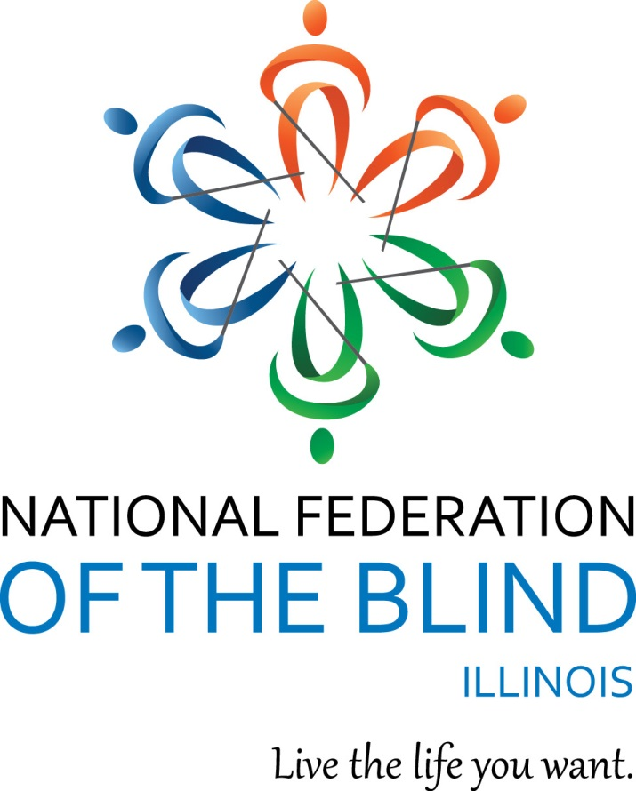

National Federation of the Blind of Illinois

State Convention 2023
“Rooted in Philosophy”

AGENDA
NATIONAL FEDERATION OF THE BLIND
OF ILLINOIS
Annual Convention
October 13-15, 2023

Naperville Marriott
1801 Naper Blvd
Naperville, IL 60563
630 505-4900
Naperville Marriott Website

The National Federation of the Blind of Illinois is thankful to our 2023 state convention sponsors.

Gold Level Sponsors:
Elburn Lions Club
https://elburnlions.com/lions-club/

North Aurora Lions Club

https://www.northauroralions.org/

Members of NFBI wish to thank the following donors for their generous gifts:

The Aileen S. Andrew Foundation

Illinois Prairie Community Foundation Inc.

Community Fund Quad Cities Mildred Crespin-Croegaert Fund

Mr. Harold W. Knapheide III, in honor of his mother, the late Mary MacDill Knapheide

Gary and Debbie Lindon Family Fund via Jewish Federation of Metropolitan Chicago

The Friends and Family of Teresa Meyer for In Memoriam Gifts

The Naperville Noon Lion's Club

Chapin Lions Club

The Chicago Lighthouse

Laura Gerdes Ehrhart

Michelmann Foundation

Richard Lansden and Roger Hickman, Trustees, The Leona Stanford Vollintine Charitable Trust

IABM, a division of the National Federation of the Blind of Illinois
NFBI Chicago chapter, a chapter of the National Federation of the Blind of Illinois

Logistics: Announcements, Registration, Information Desk, and Smoking Policy

Announcements that you wish to be made from the convention floor during sessions MUST be submitted to the information desk in the convention hall. Mary Grunwald is coordinating our information desk this year. Michal Nowicki and Kira O’Bradovich are handling the registration table at convention. Tasabih Elfaki and Michelle Ault are running our door prize table.
If you wish to reach President Marilyn Green during sessions, please text 312-343-8396.
Smoking is not permitted in convention sessions.

National Federation of the Blind of Illinois
Marilyn Green, President
5128 N. Oak Park Ave.
Chicago, IL 60656 (312) 343-8396
National Federation of the Blind of Illinois (“NFBI”)
NFBI Website
National Federation of the Blind Website

2023 Naperville Marriott Hotel/Convention Information
Naperville Marriott Website

This quick article explains the layout of the Naperville Marriott which is our convention hotel for 2023. It also gives you basic information about the facilities and amenities.

Address and Phone:
The hotel is located at 1801 N. Naper Blvd Naperville, IL 60563. The phone is: (630) 505-4900.

Sleeping Room Types:
There are two types of rooms. A Suite and a Standard Room. The suites have a parlor with a sleeper sofa and two easy chairs. The room rate for 1 King bed is $129 and the room rate for 2 Queen beds is $139 per night. All rooms have hair dryers and coffee makers. Connecting rooms are available upon request.

Keycards and Electrical Power:
This hotel is modernized. You need to insert your keycard in a slot inside your room to the side of the door to turn your power on. Leave it in the slot until you exit your room. When you remove it, the power goes off again.

Checkout:
Check in time is 3:00 p.m. Checkout time is 12:00 p.m.

Wi Fi:
There is free Wi Fi in all lobby and common areas. This includes our meeting rooms.

Facilities:
There is an indoor pool, fitness room, and Jacuzzi. There is lots of parking especially by the side door.

Layout:
If you enter through the main doors, the layout is as follows: the Starbucks is to the left. You should walk ahead to where the tiled flooring forms a cross. If you turn left at the "lobby cross" with the doors at your back, you can enter Starbucks by taking the first left. If you take a right, you can go to the elevator bank. If you pass the elevators, you head toward the meeting rooms.
From the front door, if you simply bypass the crossing of the tiled portions of the lobby and keep going straight, you will find our information desk on your left and the hotel desk on your right. If you pass both, there is a restaurant directly ahead. You can find the bar which also serves food from the restaurant by going left after passing the hotel desk. The bar will be on your right although people can also sit on the left side at this point in the lobby.
If you reorient to the lobby desk, at this point it is easier. If you are standing facing the hotel front desk, the elevator bank is down the tiled hall to the right of the front desk. There are three elevators on your left side down that hall a short way. They are fast.
Our meeting rooms are laid out past the elevator bank. Right after the elevators there is a cash machine on your left and restrooms on your right. Past those, first you come to a hallway where conference rooms A, B, and C are on your left headed away from the lobby. Conference rooms D, E, and F are on your right. Past that Hall the hall divides at a Y. There is another set of restrooms down by the other conference rooms near Bailey. If you go left, you come to Bailey-Hobson and if you go right you will get to the Naper Ballroom. We are in the Naper Ballroom on Friday, October 13 and all general sessions, the luncheon and the banquet on Saturday, October 14. Outside of the Naper Ballroom we will have exhibits and we will have our registration.
There is a dog relief area outside of the Naper room. Exit and walk a short way, then take a 45-degree left turn. There is a cement patio area on the left about 30 ft. up. At the end of the patio, you will find a grassy area with trees which will work well for dog relief. There is even a hydrant.

Braille is Beautiful - Friday
Braille is Beautiful will take place on Friday. Please feel free to reach out to Debbie Stein if you wish to participate.

Set-up for Naper Ballroom:
When you enter the Naper Room it is wider left to right and shorter going ahead from the doors. You enter at the back of the room. We will have info, sales, and IABS in the back of the room and head table/stage will be furthest from the doors by the windows. Door prize table will be on the right as you face the stage.

Have a great convention, everyone!

IABS, INFORMATION, PAC AND SALES TABLES
The information desk will be in the hotel main lobby on Friday Oct. 13 from 2:00 to 4:30 p.m., and in our general session room during general sessions. Registration will be in the hallway outside of the Naper room on Friday from 2:00 through 5:00 p.m. as well as on Saturday from 8:00 to 9:00 a.m. The sales table for IABS will be in the back during general sessions. The PAC plan table will also be in the back during general sessions. Exhibitors will be outside of our general sessions room.

Announcement:
You can help build a future of opportunity for the blind by becoming a member of our Dream Makers Circle. Your legacy gift to the National Federation of the Blind or the National Federation of the Blind of Illinois can be made in the form of a will, or living trust, an income generating gift, or by naming us as the beneficiary of a life insurance policy. For additional information, please contact Patti Chang at (773) 307-6440 or at pchang@nfb.org.

The PAC Plan allows members, affiliates, chapters, and others to give a regular and automatic donation to the Federation every month. All you need to provide is your checking, savings or credit card account identification information.

Because of the costs associated with operating the program, the minimum donation is $5 a month and there is no restriction on how much you donate.
Please sign up at the PAC table during convention to begin a new PAC contribution or to make changes to your current contribution. Your donation will help the blind live the lives they want.

Welcome to our 2023 State Convention of the National Federation of the Blind of Illinois!!!

Friday, October 13, 2023, Morning and afternoon
9:00-5:00 Exhibits - Hallway outside of Naper Ballroom
Friedman Place
Guide Dogs for the Blind
Innovative Vision Products
Safety Positive Foundation

2:00-3:30 Sculpting with Clay – Ralph Cossentino, Instructor of Figurative Sculpture at the Palette and Chisel in Chicago, Naper Ballroom

2:00-4:30 Information Table – Mary Grunwald, Hotel Lobby
3:00-6:00 Registration, Michal Nowicki, NFBI Treasurer and Kira O’Bradovich, NFBI Chicago chapter Treasurer
Hallway Outside of Naper Ballroom
4:00-5:00 Resolutions – Michal Nowicki and Dustin Cather, Co-Chairs NFBI Resolutions Committee
Naper Ballroom

October 13, 2023, Evening
5:00-7:00 General Membership Dinner and evening general session-
Cost $15, Naper Ballroom
5:00-5:10 Welcome and Announcements – Marilyn Green, President NFBI
Pledge of Allegiance
Moment of Silence, Roberta Glickman– August 26,1945 to August 22, 2023- Chicago Chapter
Adam Kazarowicz– March 11, 1980-April 7, 2023- Chicago Chapter
Vanessa Williams McDonald– February 22, 1962-April 7, 2023- Chicago Chapter
Teresa Meyer– October 9, 1955-February 26, 2023- Chicago Chapter

5:10-5:30 Dinner

5:30-6:00 Braille is Beautiful

6:00-6:30 What does it mean to be a member of the National Federation of the Blind-Kevan Worley, Manager, Project Literacy; National Federation of the Blind of Colorado and Denise Avant, Co-chair, Membership; National Federation of the Blind

7:00-11:00 IABS IDOL - Admission $5, includes your first performance
Teresa Fabre, IABS President, Naper Ballroom
Join us for the Illinois Association of Blind Students IABS Idol
Based on the popular TV show, American Idol. IABS Idol invites everyone to participate as a soloist or group and perform a song of their choice. Bring an instrument and perform your favorite song. Each performance costs $5 per person. Don't forget our “Battle of the Chapters.” This year's theme is songs related to snacks.

Saturday, October 14, 2023, Morning

Philosophy over Breakfast, Naper Ballroom

7:00-7:10 Introductions
7:10-7:30 Breakfast Served
7:30-8:00 Why are we the National Federation of the Blind– Kevan Worley, Manager, Project Literacy; National Federation of the Blind of Colorado and Patti Chang, 2nd Vice President, National Federation of the Blind of Illinois
8:00-8:30 A Candid Conversation on Canes–Sara Luna, Vice President, Illinois Association of Blind Students, a division of the National Federation of the Blind of Illinois
8:00 - 9:00 Registration
Michal Nowicki, NFBI Treasurer and Kira O’Bradovich, NFBI Chicago chapter, Treasurer
Outside of Naper Ballroom
Later registration, see Michal Nowicki in General Sessions

October 14, 2023, Morning Sessions

9:00-11:30 General Session
Naper Ballroom
9:00-9:05 Welcome and Announcements – Marilyn Green, President NFBI

9:05-9:50 National Report – Kevan Worley, CEO, Wworley Enterprises; National Rep., National Federation of the Blind
9:50-10:20 How does the National Federation of the Blind raise Expectations for Students– Joshua Olukanni, President, Minnesota Association of Blind Students and NABS Rep.; Sara Luna, Vice President, IABS, a division of the National Federation of the Blind of Illinois and 2nd Vice President, National Association of Blind Students, a division of the NFB
10:20-10:25 2024 NFB State and National Scholarship Programs – Deborah Stein and Patti Gregory Chang, Co-chairs Scholarship committee, National Federation of the Blind of Illinois
10:25-10:35 National Association of Blind Students Report – Joshua Olukanni, Board Member, National Association of Blind Students, a division of the NFB
10:35-10:40 Washington Seminar 2023 and the NFB Legislative Initiatives – Denise Avant and Dustin Cather, Federal Legislation Co-chairs, National Federation of the Blind of Illinois
10:40-10:50 My Summer at BELL Academy-Debbie Stein, BELL Coordinator, National Federation of the Blind of Illinois; Bridget Hickey, Co-Teacher, Illinois Chicago BELL Academy and the BELL students
10:50-11:10 An NFB Training Center: What to Expect-Jamie Richey, Interim Director, Blindness in New Dimensions (Blind Inc.), Minneapolis, Minnesota
11:10-11:30 The State of Rehabilitation Services for the Blind of Illinois -Kim Borowicz, Bureau Chief, Illinois Bureau of Blind Services
11:30-12:00 Break

12:00 pm-1:30pm Illinois Association of Blind Students Lunch and Business Meeting – Naper Ballroom
IABS President, Teresa Fabre
Note: All are welcome who are interested in student issues but please note that only those who have paid IABS dues may vote in elections. Please see Glenn Moore or any IABS Board Member to pay dues. We will be collecting money at the registration table and at the IABS table during convention.
12:00-12:15 Lunch
12:15-12:20 Student Excellence Award – Debbie Stein, Board Member, Illinois Association of Blind Students
12:20-12:30 2023 Scholarship Finalists – Deborah Stein and Patti Chang, Scholarship Co-chairs, National Federation of the Blind of Illinois
12:30-12:40 NABS REP. presentation, Joshua Olukanni, National Association of Blind Students
12:40-1:10 Cross the Line- Illinois Association of Blind Students
1:10-1:15 Treasurer’s Report - Glenn Moore, Illinois Association of Blind Students Board Member
1:15-1:20 Presidents Report – Sara Luna, Vice President, Illinois Association of Blind Students
1:20-1:30 Elections
Board Seat 3 currently held by Glenn Moore
Board Seat 4 Currently Held by Amari Richardson
1:30-1:35 Illinois Association of Blind Students Board of Directors Photo Op

October 14, 2022, Afternoon

Breakouts 1:45-2:50 pm

Breakout 1
1:45-2:50 Tea Time and Personal Safety Breakout
Conference Room F
Amy Wilson, CEO, Safety Positive Foundation

Breakout 2
1:45-2:50 NFB Philosophy Breakout: What is the Philosophy of the National Federation of the Blind?
Conference Room D
Denise Avant, 1st Vice President, National Federation of the Blind of Illinois

October 14, 2023, Afternoon continued

3:05-5:00 General Session, Naper Ballroom

3:05-3:10 Call to Order
3:10-3:20 Closing Remarks – Joshua Olukanni, NABS Student Representative
3:20-3:30 Closing Remarks – Kevan Worley, NFB National Representative
3:30-4:00 State Reports
Treasury Report – Michal Nowicki, Treasurer, National Federation of the Blind of Illinois
Presidents Report – Marilyn Green, President, National Federation of the Blind of Illinois
4:00-4:30 Resolutions – Michal Nowicki and Dustin Cather, Co-chairs
4:30-5:00 Elections
General Board Seats
Board Seat 1 Currently Held by Sara Luna
Board Seat 2 Currently Held by Mary Grunwald
Board Seat 3 Currently held by Steve Hastalis
Board Seat 4 Currently Held by Dustin Cather

Election of Delegate and Alternates to 2024
National Convention

5:00 Adjourned

Saturday, October 14, Evening

5:20-5:50 Scholarship Committee Meeting – President’s Room

6:00-7:00 Hospitality – Fourier Outside of Naper Ballroom

7:00 Annual Banquet -Naper Ballroom
MC – Denise Avant, 1st Vice President
National Federation of the Blind of Illinois
7:05-7:10 Welcome and Invocation – Eileen Truschke, Member, National Federation of the Blind of Illinois, Chicago chapter
7:15-7:45 Dinner
7:45-7:55 Awards-Patti Chang, 2nd Vice President, National Federation of the Blind of Illinois
7:45-8:00 Fifteen for Funds – Cathy Randall, Board member, National Federation of the Blind of Illinois
8:00-8:30 Banquet Speech – Kevan Worley, NFB National Representative
8:30-8:45 Scholarship Awards – Deborah Kent Stein and Patti Chang, Scholarship Co-chairs, National Federation of the Blind of Illinois
8:45 Adjourned

9:00-11:00 Hospitality

October 15, 2023

8:00-10:00 Scholarship Breakfast– (Finalists, Committee Members, and Invited Guests)
Conference Room D

Thank You for All You Do
Thanks to the Special Events Committee, the Sound committee, and all others who have served on committees, worked registration and information tables, secured door prizes, and appeared on the agenda. You have helped make this convention a tremendous success.

NFB PLEDGE
I pledge to participate actively in the efforts of the National Federation of the Blind to achieve equality, opportunity, and security for the blind; to support the policies and programs of the Federation; and to abide by its constitution.

One-Minute Message
The National Federation of the Blind knows that blindness is not the characteristic that defines you or your future. Every day we raise the expectations of blind people because low expectations create obstacles between blind people and our dreams. You can live the life you want; blindness is not what holds you back.

